Marketing Dive analyzes key details of the big game each year. For more coverage, view our analysis of the best and worst Super Bowl ads, or check out every commercial that ran during the game with our Super Bowl ad tracker.
Overview
66 ads shown, three more than in 2025
18 advertisers made Super Bowl debuts
$8M the approximate price of a 30-second ad
0% increase from the year prior
(Source: multiple media outlets)
Impact and results
AI.com’s ad generated 9.1X the engagement compared to the median ad. Universal Picture’s “Minions” ad was a close second, with 9.09X the engagement compared to the median ad.
(Source: EDO, based on multiple metrics such as brand search and app downloads)
Super Bowl 60 ads were 9% less likely to amuse people compared to 2025’s ads. However, ads invoking feelings of nostalgia rose 7% from 2025.
(Source: Daivid)
Brand breakdown

Freshman advertisers:
AI.com
Genspark
Liquid I.V.
MAHA Center
Pokémon
Novo Nordisk
Anthropic
Manscaped
Svedka
Base44
Ring
Xfinity
Ferrero
Grubhub
Raisin Bran
Fanatics Sportsbook
Boehringer Ingelheim
Ro
Celebrities dominated Super Bowl advertising, with 102 total celebrity appearances across 39 ads.
(Source: XR)
Winners (and Losers)

Top 5 ads from USA Today Ad Meter by sentiment

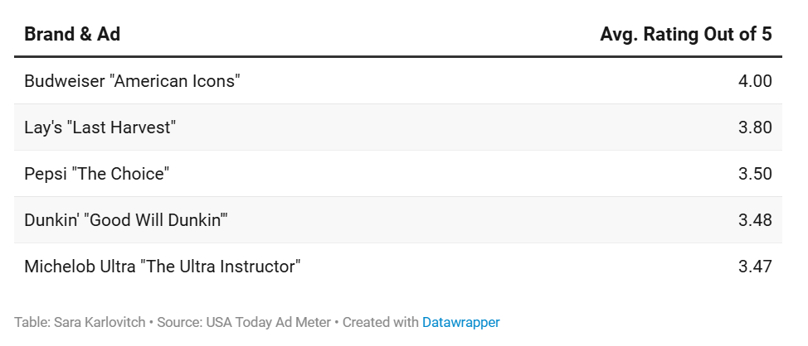

Worst 5 ads from USA Today Ad meter by sentiment

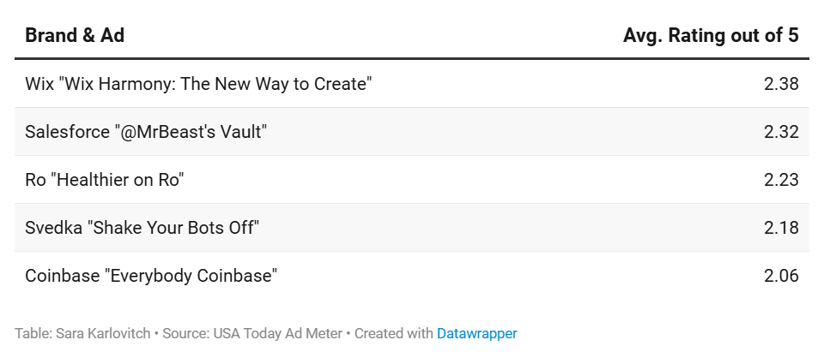

Budweiser | Super Bowl LX Commercial ‘American Icons’

https://youtu.be/a_mh-v02-Tw
″
Social listening
The Super Bowl generated $550M in earned media value for brands on social media. The game generated 764B potential impressions and an engagement rate of 0.19%
Pepsi was the most mentioned brand on social media with 38,188 mentions, followed by Apple Music and Budweiser.
(Source: Sprout Social)
Social media chatter peaked around 9:30 p.m. ET when the Seahawks secured the win with over 28M engagements.When Bad Bunny took the stage around 8:00 p.m. ET, social engagements totaled over 13.5M
(Source: Sprout Social)
Bad Bunny’s halftime show performance produced over 167M engagements, smashing the 80M generated from Kendrick Lamar’s 2025 performance.
(Source: Dash Social)

Social media sentiment by brand
News Graphics Developer Julia Himmel also contributed to this article.
